DataBridge Pro— M&E Hub for Health Programs
Befrienders Harm-Reduction Program — Giza
Q2 2026 Quarterly Report (April – June 2026)
Prepared for: UNDP / The Global Fund | Report date: July 2026

1. Executive Summary
Between April and June 2026, the Befrienders program reached 487 beneficiaries against a Q2 target of 466 (104.5% achievement) and conducted 433 HIV rapid tests during basic visits against a target of 396 (109.3% achievement). Both core indicators exceeded target.
- Beneficiaries reached: 487 (target 466) - 104.5%
- HIV rapid tests conducted during basic visits: 433 (target 396) - 109.3%
- Rapid-test positive: 7 total (6 during basic visits and 1 during follow-up)
- Confirmed, referred and linked to treatment: 5; two rapid-positive results remained unconfirmed because sample collection was declined
- No documented HIV rapid test/result during basic visits: 54 beneficiaries (11.1%)
Follow-up visits to previously enrolled beneficiaries are not counted against the Q2 reach or HIV-testing targets. They are reported separately below and in Section 6 as a continuity-of-care indicator.

2. Performance Against Q2 Targets
Indicator | Actual (Q2) | Q2 Target | Achievement
Beneficiaries Reached | 487 | 466 | 104.5%
HIV Rapid Tests Conducted (basic visits) | 433 | 396 | 109.3%
Rapid Test Positive (basic + follow-up) | 7 | - | N/A
Confirmed, Referred & Linked to Treatment | 5 | - | N/A
Rapid-positive not confirmed | 2 | - | N/A
No documented rapid test/result (basic visits) | 54 (11.1%) | - | N/A

Note on Follow-up Visits (not counted in target)
34 beneficiaries received a documented follow-up visit during Q2 (11 in April, 12 in May and 11 in June).
Follow-up visits represent continuity of care for people already enrolled and are intentionally excluded from the primary reach and HIV-test target calculations.
Follow-up activity delivered 4,870 syringes, 834 condoms and 713 lubricants, plus 2 HIV rapid tests: 1 negative and 1 rapid-positive. The rapid-positive result was not confirmed because the beneficiary declined sample collection.
Recommendation: continue tracking and reporting follow-up separately as a retention and service-continuity indicator.

3. Monthly Trend
Outreach activity increased sharply from 98 beneficiaries in April to 213 in May, then declined to 176 in June (a 17.4% decrease from May). Despite the uneven monthly pattern, total Q2 reach exceeded the quarterly target by 21 beneficiaries.
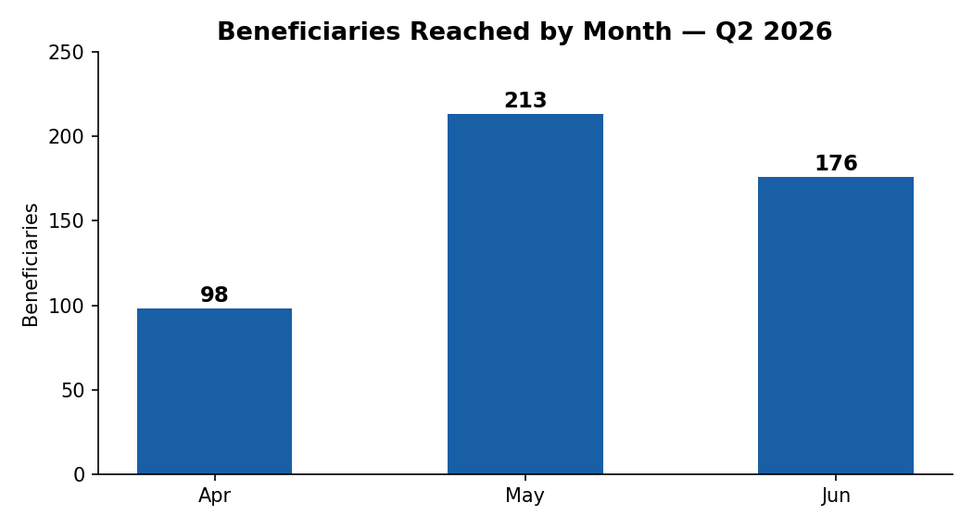
April: 98 | May: 213 | June: 176

4. Beneficiary Profile

4.1 Gender Distribution
The vast majority of beneficiaries reached were male (448, 92.0%), with 39 female beneficiaries (8.0%). This ratio is consistent with the population profile typically reached through IDU-focused outreach in Giza.
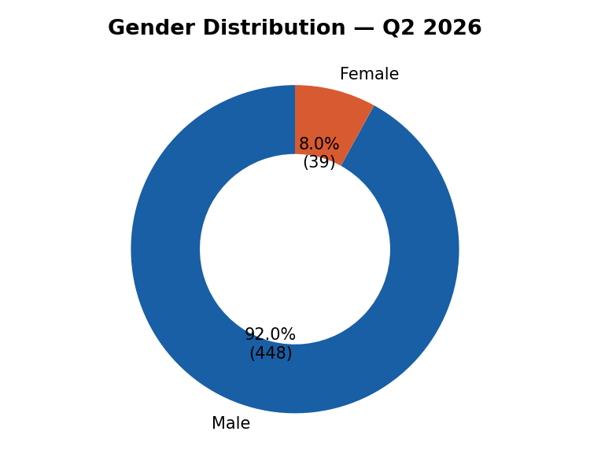

4.2 Age Distribution
The 20–44 age band accounts for the large majority of beneficiaries (440 of 487, ~90%), with the 40–44 group the single largest cohort (98 beneficiaries). Adolescents/young adults (15–19) remain a small but present group (6 beneficiaries) warranting continued targeted outreach.
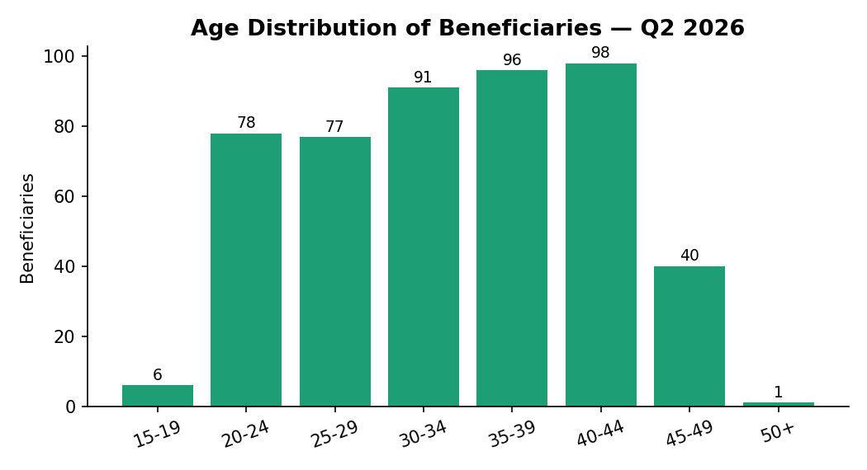

5. Geographic Coverage
After consolidating area-name variants, the geographic distribution chart presents all Q2 beneficiary contacts (basic visits plus follow-up visits) using unified area names: 6th of October (160 contacts), Al-Warraq Al-Sawahel (128), Dokki (120), Imbaba (90), Al-Haraneya (12), Bein El-Sarayat (6), Al-Haram (3), and Manshaet El-Qanater Road (2). Basic-visit target reach remains reported separately as 487 beneficiaries.
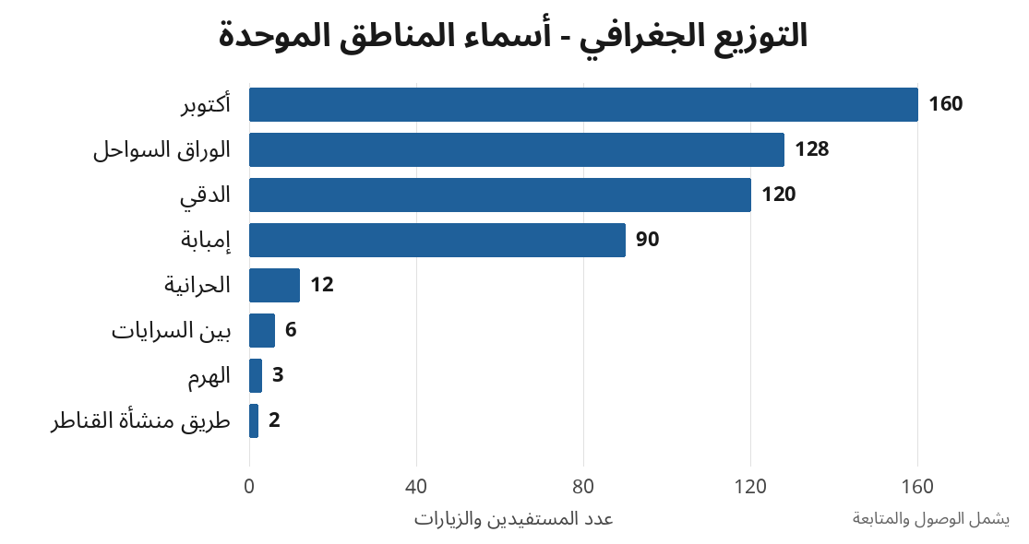

6. HIV Testing & Care Cascade
Basic-visit testing and follow-up testing are presented separately to avoid mixing different denominators. All five confirmed positive cases were linked to treatment; two rapid-positive results remained unconfirmed because the beneficiaries declined sample collection.
Step | Count | Rate / Interpretation
Beneficiaries reached (basic visits) | 487 | -
HIV rapid tests (basic visits) | 433 | 88.9% of basic reach
Rapid test - negative (basic visits) | 427 | 98.6% of basic tests
Rapid test - positive (basic visits) | 6 | 1.4% of basic tests
HIV rapid tests (follow-up visits) | 2 | Reported separately
Rapid test - positive (Q2 total) | 7 | Basic + follow-up
Confirmed, referred & linked to treatment | 5 | 71.4% of rapid-positive
Rapid-positive not confirmed | 2 | 28.6% of rapid-positive
Across basic and follow-up activity, 435 HIV rapid tests were documented: 428 negative and 7 rapid-positive. Five rapid-positive cases were confirmed, referred and linked to treatment. Two rapid-positive results (one basic visit and one follow-up visit) were not confirmed because sample collection was declined. Linkage among confirmed cases was 100% (5 of 5).

7. Prevention Commodities Distributed
Syringes remained the dominant prevention commodity, reflecting the IDU focus of the program. The revised dataset records 45,360 syringes distributed during basic visits and 4,870 during follow-up visits, for a Q2 total of 50,230.
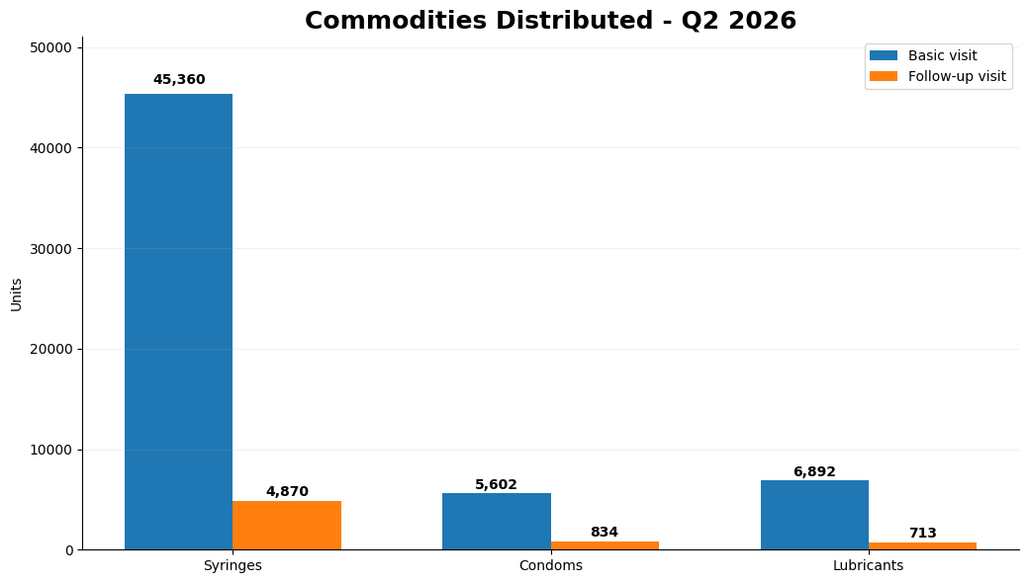
Commodity | Basic Visits | Follow-up Visits | Q2 Total
Syringes | 45,360 | 4,870 | 50,230
Condoms | 5,602 | 834 | 6,436
Lubricants | 6,892 | 713 | 7,605

8. Additional Clinical Services
Beyond HIV testing and commodity distribution, the program delivered the following complementary services across basic and follow-up visits during Q2:
Syphilis testing: 12 beneficiaries (11 basic visits and 1 follow-up visit)
Psychosocial support sessions: 10 beneficiaries (all during basic visits)
OST / methadone referrals: 4 beneficiaries (all during basic visits)

9. Data Quality and Progress Against Annual Targets

Following the latest review meeting, six date-related outliers were corrected using DataBridge Pro by cross-checking beneficiary codes against the recorded ages. Manual validation of the revised dataset also found no remaining extreme syringe-distribution outliers. The two previously identified 1,510-unit syringe entries were corrected to 150 units.

One high-value follow-up condom record—144 requested and 144 provided—is internally consistent but should be verified against the original source form. The DataBridge Pro data-quality assessment should be rerun on the revised dataset before final submission.

Confirmatory-test and treatment-referral fields are blank in 98.8%–99.0% of basic-visit records. This is expected because these fields apply only to rapid-positive cases, rather than to the full beneficiary population.

Blank commodity-quantity fields occur in 20.5% of condom records, 19.9% of lubricant records, and 2.1% of syringe records. These blanks largely correspond to records where both need and provision were marked “No” and should therefore be treated as not applicable rather than as refusal-related missing data.

Fifty-four basic-visit records (11.1%) have no documented rapid-test result. The dataset confirms that no test or result was recorded, but it does not document the reason. These records should not be classified as test refusals without a specific reason field.

Progress Against Annual Targets

By the end of Q2 2026, the program had reached 905 beneficiaries against an annual target of 2,024, representing 44.7% achievement. An additional 51 follow-up visits were documented, bringing the total number of beneficiary contacts to 956. Follow-up visits are reported separately and are not counted against the annual reach target.

A total of 770 HIV rapid tests were documented during the first half of the year. This figure comprises 764 tests conducted during basic visits and 6 tests conducted during follow-up visits. Follow-up tests are excluded from annual target achievement calculations. Therefore, 764 HIV tests are counted against the annual target of 1,721, representing 44.4% achievement.

Follow-up visits and follow-up HIV tests are reported separately and excluded from annual target achievement calculations.

Indicator | Annual Target | Counted Result to End of Q2 | Achievement | Remaining
Beneficiaries reached | 2,024 | 905 | 44.7% | 1,119
HIV tests counted against target | 1,721 | 764 | 44.4% | 957

10. Conclusion & Recommendations

- Both headline Q2 targets were exceeded: beneficiary reach achieved 104.5% and basic-visit HIV testing achieved 109.3%.
- Continue reporting follow-up activity (34 beneficiaries) as a separate continuity-of-care indicator and do not merge it into primary reach or testing-target calculations.
- Review the monthly pattern: activity rose from 98 in April to 213 in May and then fell by 17.4% to 176 in June. Investigate staffing, site access and operational scheduling before Q3 planning; seasonality cannot be concluded from one quarter alone.
- The rapid-positive result identified during follow-up demonstrates the value of continuity-of-care visits. However, that result remained unconfirmed because sample collection was declined and should not be reported as linked to treatment.
- Before submission, verify the 144-condom follow-up record against the source form and rerun the DataBridge quality assessment on the revised dataset.

Prepared from IDUs Database - Befrienders - 2026 (revised source) | Validated 2026-07-08

